VOCABULARY
1. Complete the words (places in a city) to make sentences.
1. We are at the … … … … … … … … . There are amazing fish here.
2. My father likes to meet his friends at the … … … for a drink.
3. My mother buys fruit and vegetables at the local … … … … … … .
4. I want to see the lions at the … … … .
5. You buy medicine at the … … … … … … …’ … .
6. On holiday, people often sleep in a … … … … … .
7. You can buy many different things at a d … … … … … … … … … s … … … … .
2. Look at the pictures of Carol and Tom. What are they doing?
taking a nap • taking photos • ordering a pizza • hanging out • buy tickets
getting a haircut • stay at home • going on a ride • go bowling • waiting in a queue

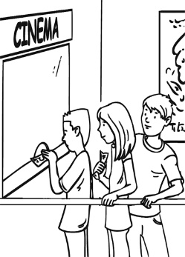  1  2  3  4  5 |  | 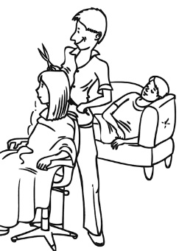 |  | 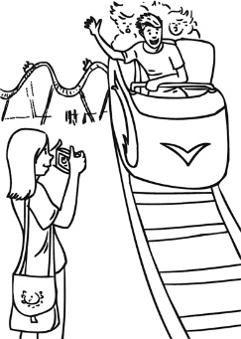 |  | 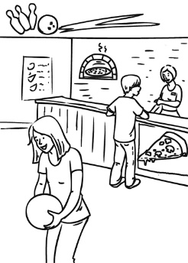 |  | 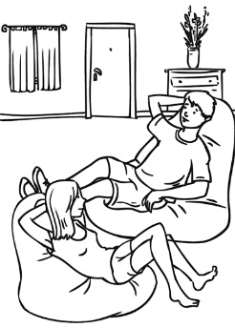
1. Carol and Tom are ………………………..……… . They want to …………………………… for a film.
2. They are at the hairdresser’s. She is ……………….………… and Tom is ……….……….………… .
3. They are at the theme park. Carol is …………..…………… of Tom. He is ……………….………… .
4. They are at the bowling alley, but Tom doesn’t want to ………………… . He is ……………………… .
5. Carol isn’t going out tonight. She wants to ……………………… . So they are ……………………… .
Grammar
3. Complete the sentences with relative pronouns. There may be more than one correct answer.
1. Is this the cake ………………… you baked?
2. That’s the palace ………………… the queen lives.
3. Sam is the student ………………… biology project won a prize.
4. My sister has got a friend ………………… plays the drums in a pop group.
5. I will never forget the day ………………… my baby sister was born.
6. I want to buy the electric shaver ………………… is on the top shelf, please.
7. Mrs Wilson is the teacher ………………… tests are always very hard.
8. The dentist ………………… checks my teeth works at this clinic.
9. This is the restaurant … we had dinner twice last week.
10. Is Tom the boy ………………… surfboard got lost at the weekend?
11. Do you know the people ………………… live on the 8th floor in your building?
12. An evergreen tree is a tree …………….. doesn’t lose its leaves in winter.
SEND IT TODAY TO:mailto:montseformystudents@gmail.com

